Project 4 Report
CS 316
Authors: Matthew Melton and JT Reagor

Thumbnail image:
CSS:
.menu figcaption{
position: absolute;
visibility: hidden;
padding: 10px;
width: 200px;
}
.menu figcaption p{
font-size: 22px;
text-align: center;
margin: 5px;
background-color:#c2bca9;
}
.menu figure:hover figcaption{
border-style: solid;
border-width: 3px;
border-color: #201E1F;
border-radius: 3px;
visibility: visible;
background: #E7DFC6;
}

HTML:

<figure>
<img src="Photos/cru_logo.jpeg" alt="Cru Logo">
<figcaption>
<img src="Photos/cru_logo.jpeg" alt="Cru Logo">
<p>This is Cru's Logo!</p>
</figcaption>
</figure>

Screenshot:


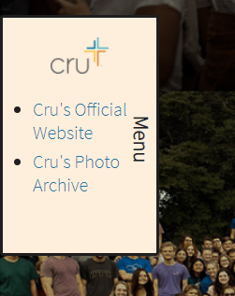

Transition:

CSS:

.menu{
background: #FEEFDD;
border-style: solid;
border-width: 3px;
border-color: #201E1F;
border-radius: 3px;
width: 130px;
position: absolute;
left: -110px;
transition: left .6s ease-out;
min-height: 200px;
}
.menu:hover{
left: 0px;
transition: left .6s ease-out;
}

HTML:
<nav class="menu">
<p id="navLabel">Menu</p>
<figure>
<img src="Photos/cru_logo.jpeg" alt="Cru Logo">
<figcaption>
<img src="Photos/cru_logo.jpeg" alt="Cru Logo">
<p>This is Cru's Logo!</p>
</figcaption>
</figure>
<ul>
<li><a href="https://www.cru.org/">Cru's Official Website</a></li>
<li><a href="https://cluster.co/c/nJ2z6pp0WMk/">Cru's Photo Archive</a></li>
</ul>
</nav>

Screenshot:

